Experiment n°5

Head losses comparison for different technical solutions

# Objective

The aim of this experiment is to highlight singular head losses in a hydraulic circuit.

# Description of the installation

The HD98B Hydraulic bench is used for this experiment. Pipe n°9, 6 and 5 will be used.

# Theories

Head losses follow the Darcy-Weisbach formula:

$$∆Ps=ξ*\frac{L}{D}*\frac{1}{2}*ρ*Um²$$

For head losses induced by a single component in the circuit (singular head losses) the formula is:

$∆Ps=K*\frac{1}{2}ρUm²$ K singular head losse coefficient

This formula is applicable for one singularity in the circuit, for example: if a circuit is equipped with 2 elbows and one valve, the formula is

$$∆Ps=(2Kelbow+Kvalve)*\frac{1}{2}ρUm²$$

For a singularity in the circuit, the coefficient K is given by the following formulas:

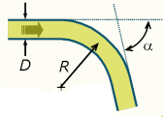Rounded elbow:

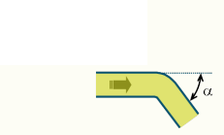K= $\frac{α}{π}[0.131+1.847*{(\frac{D}{R})}^{7/2}$

Elbow:

K= ${(sin{α})}^{2}+2{(sin{\frac{α}{2}})}^{4}$

Rough entry:

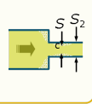K=0.5

Rough narrowing:

K= ${\left(\frac{1}{\frac{Sc}{S2}-1}\right)}^{2}$

# Experiment

1. Check the opening of the exit valve;
2. Connect the U-shaped manometer to the desired singularity;
3. Adjust the flow rate by opening different pipes;
4. Pick up the value of the manometer;

Fill the following table:

|  |  |  |  |  |  |
| --- | --- | --- | --- | --- | --- |
| Qv m3/s | h1 mm | h2 mm | Δh m | K measured | K theoretical |